PRESS RELEASE

COMMUNICATIONS AND MEDIA TEAM OF THE ASEAN SUMMIT 2023

No.78/SP/TKM-ASEAN2023/ENG/5/2023

42nd ASEAN Summit 2023 Agrees on Migrant Worker Protection and Myanmar Conflict Resolution

West Manggarai, 11 May 2023 – Indonesian President Joko Widodo affirmed that the protection of migrant workers and victims of human trafficking is one of the three points of agreement resulting from the 42nd ASEAN 2023 Summit that has just concluded in Labuan Bajo, West Manggarai, East Nusa Tenggara (NTT), Thursday (11/5/2023).
"What directly affects the interests of the people is of vital concern to the leaders. I invite ASEAN countries to take firm action against the main perpetrators," President Jokowi said at a press conference at the conclusion the 42nd ASEAN Summit 2023 at the Media Centre, Bintang Flores Hotel, Labuan Bajo.
Second, the President said, ASEAN voices are unanimous in stating that violation of humanitarian values cannot be tolerated. The Five-point Consensus mandates ASEAN to engage with all stakeholders. Inclusivity must be strongly held by ASEAN because ASEAN's credibility is at stake.
Indonesia, President Jokowi said, is ready to talk to anyone including the Myanmar military junta and all stakeholders in Myanmar for humanitarian interests. No party inside or outside ASEAN should take advantage of the internal conflict in Myanmar. Violence must be stopped and the people must be protected.
"What is important for me to emphasise is that engagement is not recognition. Engaging does not mean giving recognition. I said at the meeting that ASEAN unity is very important. Without unity, it would be easy for other parties to divide ASEAN," the President said.
Third, strengthening economic cooperation. ASEAN, President Jokowi said, has agreed to build an electric car ecosystem and become an important part of the world supply chain, so that downstream industry is the key.
In addition, ASEAN leaders agreed to strengthen the implementation of local currency transactions and digital payment connectivity between countries. The President said that this is in line with the goal of ASEAN centrality so that ASEAN will be stronger and more independent.
On that occasion, the President expressed that he is pleased the 42nd ASEAN Summit 2023 in Labuan Bajo went successfully and smoothly. Indonesia, the President said, wants to see ASEAN strong, able to face challenges, responsive to dynamics, and continue to play a central role in the region.
"ASEAN is one family. Its bond is very strong, its unity is very important to sail towards the same goal, making ASEAN the epicentrum of growth and a peaceful, stable, and prosperous region," President Jokowi said.

***

Director of Information and Media of the Ministry of Foreign Affairs - Hartyo Harkomoyo (+62811831899).

Get more information at http://asean2023.id, https://infopublik.id/kategori/asean-2023, and https://indonesia.go.id/kategori/ragam-asean-2023

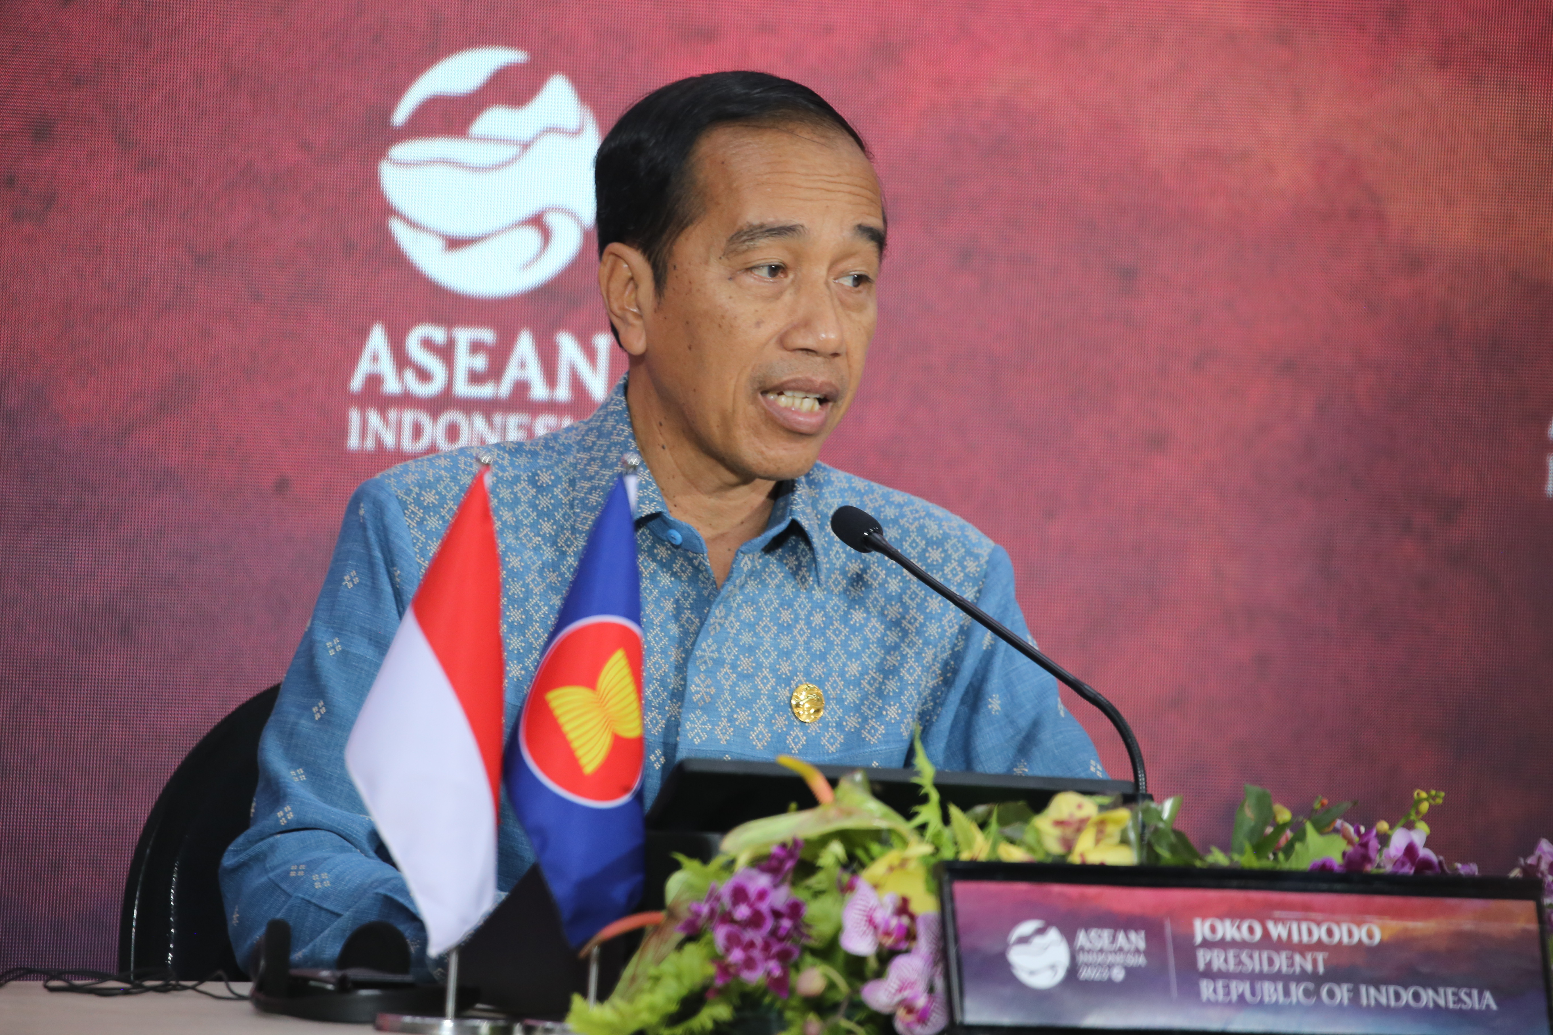
Indonesian President Joko Widodo affirmed that the protection of migrant workers and victims of human trafficking is one of the three points of agreement resulting from the 42nd ASEAN 2023 Summit that has just concluded in Labuan Bajo, West Manggarai, East Nusa Tenggara (NTT), Thursday (11/5/2023). (Photo: Agus Siswanto/InfoPublik)

